CHAPTER 6: The mysterious universe
Worksheet 6.1

Observing stars
Student: Class:
1. Three types of celestial objects are illustrated below. Identify and outline the nature of each.
(a) | 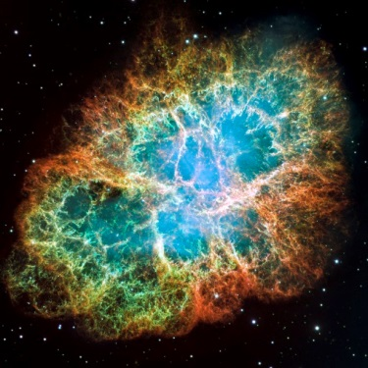 | Name:  Outline:
(b) | 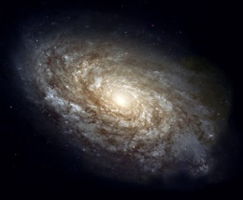 | Name:  Outline:
(c)  Photos:  Top: creativemarc / 123RF  Centre: NASA, Hubble Heritage Team, STScI  Bottom: Yuri Beletsky / NASA | 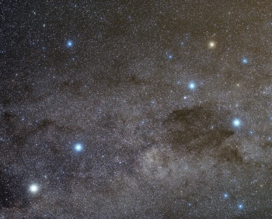 | Name:  Outline:
CHAPTER 6: The mysterious universe
Worksheet 6.1

Page 2

2. The following diagram shows the effect of parallax on the observation of a close star (S) from two locations (X and Y) in the Earth’s orbit around the sun.
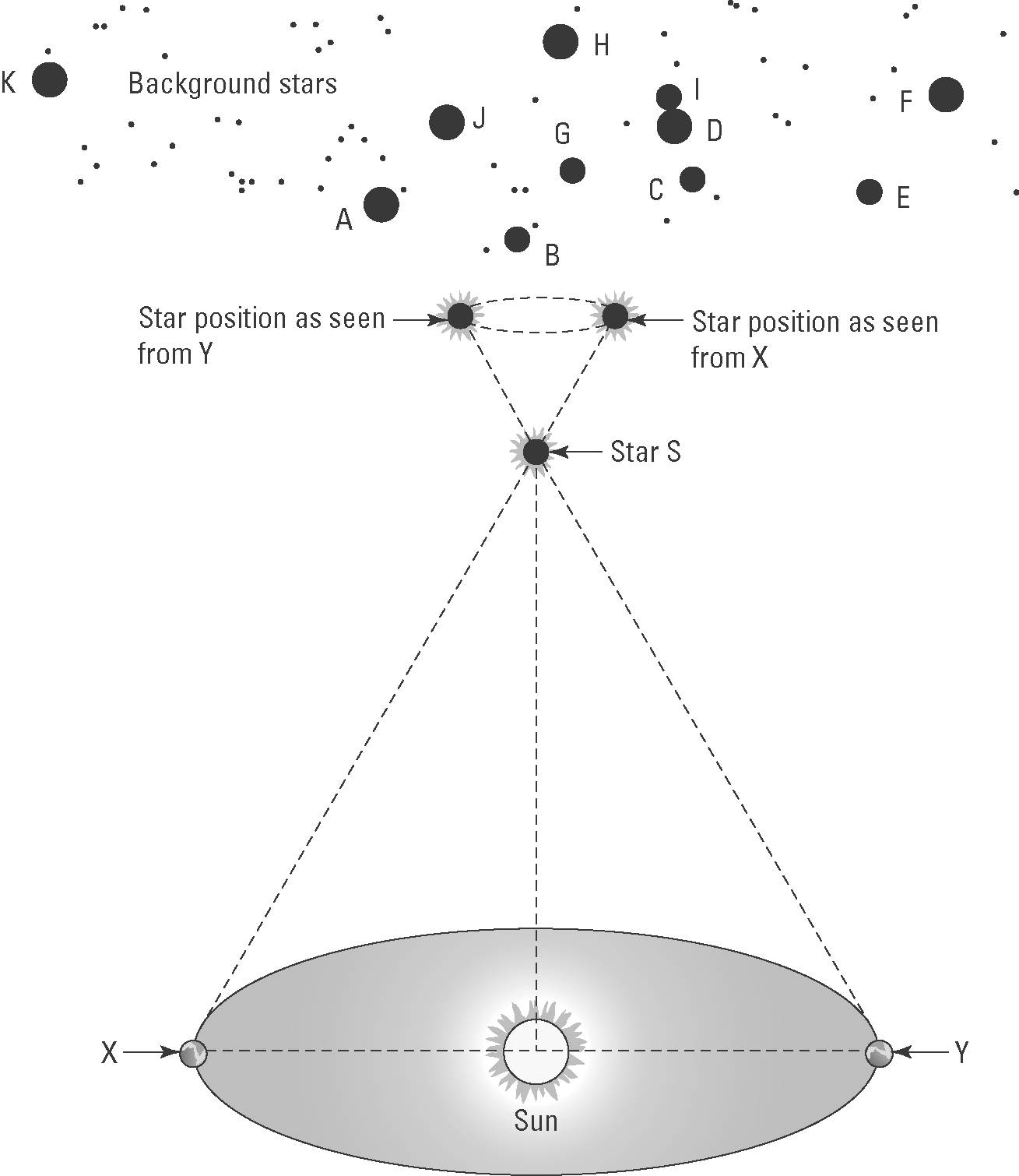
(a) The Earth is shown in two positions X and Y. How long does it take for the Earth to move from X to Y?

(b) Explain the meaning of parallax in relation to the apparent motion of stars.

(c) Before 1837 it was believed that all stars existed on a transparent celestial sphere at a fixed distance from the Earth. How did the observation of parallax of close stars change this view?

(d) Outline the motion of the stars as seen by an observer on Earth during the time taken to travel from X to Y.

